Chapter 15. Campus Design Implementation
This chapter covers the following key topics:
- VLANs—
The chapter begins with a range of virtual LAN (VLAN)-related topics from using VLANs to create a scalable design to pruning VLANs from trunk links.
- Spanning Tree—
Covers important Spanning Tree issues that are essential to constructing a stable network.
- Load Balancing—
Discusses the five techniques available for increasing campus network bandwidth.
- Routing/Layer 3 Switching—
Discusses issues such as MLS (routing switches) and switching routers.
- ATM—
Examines valid reasons for using ATM in your campus network and how to deploy it in a scalable fashion.
- Campus Migrations—
Provides recommendations for migrating your campus network.
- Server Farms—
Covers some basic server farm design principles.
- Additional Campus Design Recommendations—
Discusses several other design issues such as VTP, port configurations, and passwords.
This chapter is designed to be a compendium of best practice for campus design. It draws on the collective wisdom of many people and many attempts at achieving the elusive goal of a perfect campus design. It is intended to be a concentrated shot of what has been proven to work well, and what has been proven to be a flop. The hope is that it will serve not only as an eye-opener, but as something that you will return to whenever you face campus design decisions.
The material in other chapters has, in some form, implied many of the items discussed in this chapter. Therefore, this chapter does not attempt to fully explain the background of every point (that is the job of the previous 14 chapters!). Instead, each point is fairly concise and uses references and pointers to other chapters for more detail.

VLANs
When the word switching is brought up, the first thing that comes to most network engineer's minds is the subject of VLANs. The use of VLANs can make or break a campus design. This section discusses some of the most important issues to remember when designing and implementing VLANs in your network.

The Appropriate Use of VLANs
Given that VLANs are associated so closely with switching, people most often think of what Chapter 14, "Campus Design Models," referred to as campus-wide VLANs. Given the popularity of campus-wide VLANs as both a concept and a design, this section discusses its pro and cons, as well as an alternate design for consideration.
The popularity of campus-wide VLANs is due in large part to several well-publicized benefits to this approach. First, it can allow direct Layer 2 paths between all of the devices located in the same community of interest. By doing so, this can remove routers from the path of high-volume traffic such as that going to a departmental file server. Assuming that software-based routers are in use, there is the potential for a tremendous increase in available bandwidth.
Second, campus-wide VLANs make it possible to use technology like Cisco's User Registration Tool (URT). By functioning as a sophisticated extension to the VLAN membership policy server (VMPS) technology discussed in Chapter 5, "VLANs," URT allows VLAN placement to be transparently determined by authentication servers such as Windows NT Domain Controllers and NetWare Directory Services (NDS). Organizations such as universities have found this feature very appealing because they can create one or more VLANs for professors and administrative staff while creating separate VLANs for students. Consequently, the same physical campus infrastructure can be used to logically segregate the student traffic while still allowing the use of roving laptop users.
The third benefit of campus-wide VLANs is actually implied by the second benefit—campus-wide VLANs allow these roving users to be controlled by a centralized set of access lists. For example, a university using campus-wide VLANs might utilize a pair of 7500 routers located in the data center for all inter-VLAN routing. As a result, access lists between the VLANs only need to be configured in two places. Consider the alternative where routers (or Layer 3 switches) might be deployed in every building on campus. To maintain user mobility, each of these routers needs to be configured with all of the VLANs and access lists used throughout the entire campus. This can obviously lead to a situation where potentially hundreds of access lists must be maintained.
Tip
Although campus-wide VLANs have several well-publicized benefits and are quite popular, they create many network design and management issues. Try to avoid using campus-wide VLANs.

Although these advantages are very alluring, many organizations that implement this approach quickly discover their downsides. Most of the disadvantages are the result of one characteristic of campus-wide VLANs: a lack of hierarchy. Specifically, this lack of hierarchy creates significant scalability problems that can affect the network's stability and maintainability. Furthermore, these problems are often difficult to troubleshoot because of the dynamic and non-deterministic nature of campus-wide VLANs (not to mention that it can be difficult to know where to start troubleshooting in a flat network). For more information on these issues, please refer to Chapter 14, "Campus Design Models," Chapter 11, "Layer 3 Switching," and Chapter 17, "Case Studies: Implementing Switches."
Although many books and vendors discuss campus-wide VLANs as simply the way to use switching, Layer 3 switching introduces a completely different approach that is definitely worthy of consideration. Chapter 14 discussed these Layer 3 approaches under the heading of the multilayer campus design model. Although this approach cannot match the support for centralized access lists available under campus-wide VLANs, it can allow you to build and maintain much larger networks than is typically possible with campus-wide VLANs. Layer 3 switching can also be used with the Dynamic Host Control Protocol (DHCP), a very proven and scalable technique for handling user mobility (see the next section). Therefore, as a general rule of thumb, use the multilayer model as your default design choice and only use flat earth designs if there is a compelling reason to justify the risks. For more information on the advantages and implementation details of the multilayer model, see Chapter 11, Chapter 14, and Chapter 17.
Note that this implies a fundamental difference in how VLANs are used between the two design models. In the case of campus-wide VLANs, VLANs are used to create logical partitions unique to the entire campus network. In the case of the multilayer model, they are used to create logical partitions that may be unique to a single IDF/access layer wiring closet.
Tip
The multilayer design model uses VLANs in a completely different fashion from the campus-wide VLANs model. In the multilayer model, VLANs are very often only unique to a single IDF device whereas campus-wide VLANs are globally unique.

Use DHCP to Solve User Mobility Problems
Many network engineers feel that campus-wide VLANs are the only way to handle mobile users and unwittingly saddle themselves with a flat network that requires high maintenance. As mentioned in the previous section, many user-mobility problems can be solved with DHCP. Because DHCP fits well into hierarchical designs that utilize Layer 3 processing for scalability, it can be a much safer choice than using campus-wide VLANs. As discussed in Chapter 11 and Chapter 17, the use of DHCP simply requires one or more ip helper-address statements on each router (or Layer 3 switch) interface. When using IP helper addresses for DHCP, consider using the no ip forward-protocol command to disable the forwarding of unwanted traffic types that are enabled by default (the ip helper-address command automatically enables forwarding of the following UDP ports: 37, 49, 53, 67, 68, 69, 137, and 138). Most commonly, UDP ports 137 and 138 are removed to prevent excessive forwarding of NetBIOS name registration traffic.
Tip
Be careful to not simply enter no ip forward-protocol upd. Prior to 12.0, entering this command disabled all of the default UDP ports, including ports 67 and 68 that are used by DHCP. Although no ip forward-protocol upd does not disable DHCP in early releases of 12.0, proceed with caution. For an example of ip helper-address and no ip forward-protocol, see Chapter 17.

VLAN Numbering
Although VLAN numbering is a very simple task, having a well thought-out plan can help make the network easier to understand and manage in the long run. In general, there are two approaches to VLAN numbering:
- Globally-unique VLAN numbers
- Pattern-based VLAN numbers
In globally-unique VLAN numbers, every VLAN has a unique numeric identifier. For example, consider the network shown in Figure 15-1. Here, the VLANs in Building 1 use numbers 10–13, Building 2 uses 20–23, and Building 3 uses 30–33.

Figure 15-1 Globally-Unique VLANs
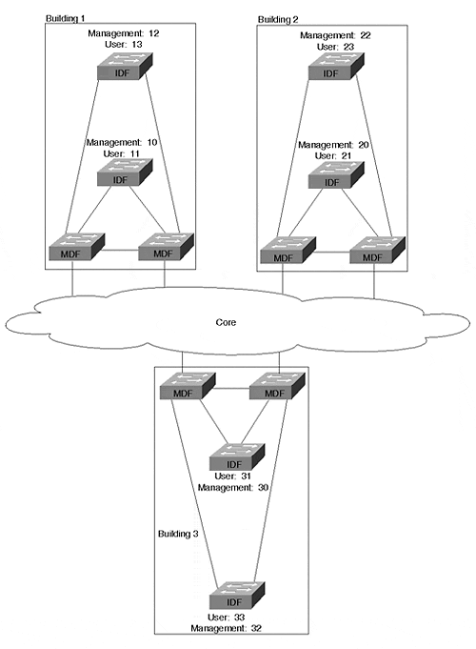
Tip
When using globally-unique VLANs, try to establish an easily remembered scheme such as the one used in Figure 15-1 (Building 1 uses VLANs 1X, Building 2 uses 2X, and so on).

In the case of pattern-based VLAN numbers, the same VLAN number is used for the same purpose in each building. For example, Figure 15-2 shows a network where the management VLAN is always 1, the first end user VLAN is 2, the second end user VLAN is 3, and so on.

Figure 15-2 Pattern-Based VLANs
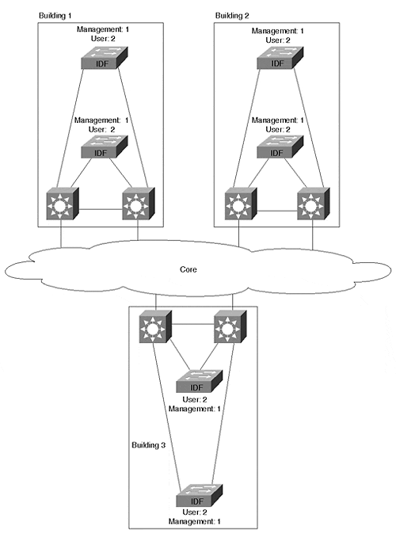
Which approach you use is primarily driven by what type of design model you adopt. If you have utilized the campus-wide VLANs model, you are essentially forced to use globally-unique VLAN numbers. Although there are special cases and "hacks" where this may not be true, not using unique VLANs in flat designs can lead to cross-mapped VLANs and widespread connectivity problems.
Tip
Use globally-unique VLAN numbers with campus-wide VLANs.

If you are using the multilayer model, either numbering scheme can be adopted. Because VLANs are terminated at MDF/distribution layer switches, there is no underlying technical requirement that the VLAN numbers must match (this is especially true when using using switching router platforms such as the Catalyst 8500). In fact, even if the VLAN numbers do match, they are still maintained as completely separate broadcast domains because of Layer 3 switching/routing. If you like the simplicity of knowing that the management VLAN is always VLAN 1, the pattern-based approach might be more appropriate. On the other hand, some organizations prefer to keep every VLAN number unique just as every IP subnet is unique (this approach often ties the VLAN number to the subnet number—for example, VLAN 25 might be 10.1.25.0/24). In other cases, a blend of the two numbering schemes works best. Here, organizations typically adopt a single number for use in all management VLANs but use unique numbers for end-user VLANs.
Tip
The multilayer model can be used with both globally-unique VLANs and pattern-based VLANs.

Use Meaningful VLAN Names
Although common sense dictates that clearly-named VLANs serve as a form of documentation, networks are frequently built with useless VLAN names. Recall from Chapter 5 that if you do not specify a VLAN name, the Catalysts use a very creative name such as VLAN0002 for VLAN 2 and VLAN0003 for VLAN3. In other cases, organizations do specify a VLAN name as a parameter to the set vlan command, but the names are cryptic or poorly maintained.
It is usually a far better choice to create VLAN names that actually describe the function of that broadcast domain. This is especially true when using campus-wide VLANs and globally-unique VLAN numbers. The dynamic and non-hierarchical nature of these networks makes troubleshooting challenging enough without having to waste time trying to determine what VLAN a problem involves. Having clearly-defined and descriptive VLAN names can save critical time during a network outage (as well as avoiding the confusion that might cause an administrator to misconfigure a device and thus create a network outage).
Tip
Descriptive VLAN names are especially important when using campus-wide VLANs.

Although VLAN names are less important when the multilayer design model is in use, the names should at least differentiate management and end-user traffic. Try to include the name of the department or IDF/access layer closet where the VLAN is used. Also, some organizations like to include the IP subnet number in the VLAN name.

Use Separate Management VLANs
When first exposed to VLANs, many network administrators find them confusing and therefore decide to adopt a policy of placing only a single VLAN on every switch. Although this can have an appealing simplicity, it can seriously destabilize your network. In short, you want to always use at least two VLANs on every Layer 2 Catalyst switch. At a minimum, you want one VLAN for management traffic and a separate VLAN for end-user traffic.
Tip
Make sure every Layer 2 switch participates in at least two VLANs: one that functions as the management VLAN and one or more for end-user VLANs.

However, this is not to suggest that having more than two VLANs is a good idea. To the contrary, the simplicity of maintaining a single end-user VLAN (or at least a small number) can be very beneficial for network maintenance.
Why, then, is it so important to have at least two VLANs? Think back to the material discussed in Chapter 5 regarding the impact of broadcasts on end stations. Because broadcasts are not filtered by hardware on-board the network interface card (NIC), every broadcast is passed up to Layer 3 using an interrupt to the central CPU. The more time that the CPU spends looking at unwanted broadcast packets, the less time it has for more useful tasks (like playing Doom!).
Well, the CPU on a Catalyst's Supervisor is no different. The CPU must inspect every broadcast packet to determine if it is an ARP destined for its IP address or some other interesting broadcast packet. However, if the level of uninteresting traffic becomes too large, the CPU can become overwhelmed and start dropping packets. If it drops Doom packets, no harm is done. On the other hand, if it drops Spanning Tree BPDUs, the whole network could destabilize.
Note
Note that this section is referring to Layer 2 Catalysts such as the 2900s, 4000s, 5000s, and 6000s. Because these devices currently have one IP address that is only assigned to a single VLAN, the selection of this VLAN can be important. On the other hand, this point generally does not apply to router-like Catalysts such as the 8500. Because these platforms generally have an IP address assigned to every VLAN, trying to pick the best VLAN for an IP address obviously becomes irrelevant. For more information on the Catalyst 8500, see Chapter 11.

In fact, this Spanning Tree problem is one of the more common issues in flat earth campus networks. The story usually goes something like this: The network is humming along fine until a burst of broadcast data in the management VLAN causes a switch to become overwhelmed to the point where is starts dropping packets. Because some of these packets are BPDUs, the switch falls behind in its Spanning Tree information and inadvertently creates a Layer 2 loop in the network. At this point, the broadcasts in the network go into a full feedback loop as discussed in Chapter 6, "Understanding Spanning Tree."
If this loop occurs in one or more VLANs other than the management VLAN, it can quickly starve out all remaining trunk bandwidth throughout the entire campus in a flat network. However, the Supervisor CPUs are insulated by the VLAN switching ASICs and continue operating normally (recall that all data forwarding is handled by ASICs in Catalyst gear).
On the other hand, if the loop occurs in the management VLAN (the VLAN where SC0 is assigned), the results can be truly catastrophic. Suddenly, every switch CPU is hit with a tidal wave of broadcast traffic, completely crushing every switch in a downward spiral that virtually eliminates any chance of the network recovering from this problem. If a network is utilizing campus-wide VLANs, this problem can spread to every switch within a matter of seconds.
Note
Recall that SC0 is the management interface used in Catalyst switches such as the 4000s, 5000s, and 6000s. This is where the management IP address is assigned to a Catalyst Supervisor. Because the CPU processes all broadcast packets (and some multicast packets) received on this interface, it is important to not overwhelm the CPU.

How do you know if your CPU is struggling to keep up with traffic in the network? First, you can use the Catalyst 5000 show inband command (this is used for Supervisor IIIs; use show biga on Supervisor Is and IIs [biga stands for Backplane Interface Gate Array]) to display low-level statistics for the device. Look under the Receive section for the RsrcErrors field. This lists the number of received frames that were dropped by the CPU. Second, to view the load directly on the CPU, use the undocumented command ps -c. The final line of this display lists the CPU idle time (subtract from 100 to calculate the load). Note that ps-c has been replaced by show proc cpu in newer images.
Tip
Use the show inband, show biga, ps -c, and show proc cpu commands to determine if your CPU is overloaded.

If you find that you are facing a problem of CPU overload, also read the section "Consider Using Loop-Free Management VLANs" later in this chapter.

Deciding What Number Should be Used for the Management VLAN
A common question surrounds the issue of VLAN numbering for the management VLAN. To appropriately answer this question, you must consider the three types of traffic that pass through Catalyst switches:
- Control traffic
- Management traffic
- End-user traffic
Control traffic encompasses plug and play-oriented protocols such as DISL/DTP (used for trunk state negotiation), CDP, PAgP, and VTP. These protocols always use VLAN 1.
Management traffic includes end-to-end and IP-based protocols such as Telnet, SNMP, and VQP (the protocol used by VMPS). These protocols always use the VLAN assign to SC0.
End-user traffic is all of the remaining traffic on your network. Obviously, this represents the majority of traffic on most networks.
The overriding principle concerning Management VLAN design is to never mix end-user traffic with the control and management traffic. Failing to abide by this rule will open your network up to the sort of network meltdown scenarios discussed in the previous section.
Tip
Never mix end-user traffic with control and management traffic.

When implementing this principle, you must generally choose one of two designs:
- Use VLAN 1 for all control and management traffic while placing end-user traffic in other VLANs (VLANs 2–1000).
- Use VLAN 1 for control traffic, another VLAN (such as VLAN 2) for management traffic, and the remaining VLAN for end-user traffic (such as VLAN 3–1000).
The first option combines control and management traffic in VLAN 1. The advantage of this approach is management simplicity (it is the default setting and uses a single VLAN). The primary disadvantage of this approach centers around the default behavior of VLAN 1—because VLAN 1 cannot currently be removed from trunk links, it is easy for this VLAN to become extremely large. For example, the use of Ethernet trunks throughout a network along with MLS Layer 3 switching in the MDF/distribution layer will result in VLAN 1 spanning every link and every switch in the campus, exactly what you do not want for your all-important management VLAN. Therefore, placing SC0 in such as large and flat VLAN can be risky.
Note
Although VLAN 1 cannot be removed from Ethernet trunks in current versions of Catalyst code, Cisco is developing a feature that will provide this capability in the future. In short, this feature is expected to allow VLAN 1 to be removed from both trunk links and the VTP VLAN database. Therefore, from a user-interface perspective, enabling this feature effectively removes VLAN 1 from the device. However, from the point of view of the Catalyst internals, the VLAN will actually remain in use, but only for control traffic such as VTP and CDP (for example, a Sniffer will reveal these packets tagged with a VLAN 1 header on trunk links). In other words, this feature will essentially convert VLAN 1 into a "reserved" VLAN than can only be used for control traffic.

This risk can be avoided with the second option where the control and management traffic are separated. Whereas the control traffic must use VLAN 1, the management traffic is relocated to a different VLAN (many organizations choose to use VLAN 2, 999, or 1000). As a result, SC0 and the CPU will be insulated from potential broadcast problems in VLAN 1. This optimization can be particularly important in extremely large campus networks that are lacking in Layer 3 hierarchy.
Tip
For the most conservative management/control VLAN design, only use VLAN 1 for control traffic while placing SC0 in its own VLAN (in other words, no end-user traffic will use this VLAN).
Also, when using the upcoming feature that "removes" VLAN 1 from a Catalyst, you are effectively forced to use this approach.

Be Careful When Moving SC0's VLAN
Although some traffic always uses VLAN 1, other management traffic changes VLANs as SC0 is reassigned. This includes all of the end-to-end protocols (as opposed to the link-by-link protocols that only use VLAN 1) such as:
- Telnet
- SNMP
- The VQP protocol used by VMPS
- Syslog
- Ping
For these protocols to function, SC0 must be assigned to the correct VLAN with a valid IP address and one or more functioning default gateways to reach the rest of the network. The most common problem here is that people often move SC0 to a different VLAN for troubleshooting purposes and forget to move it back when they are done. Although this can help troubleshoot the immediate problem, it is almost guaranteed to create more problems! Another common problem is failing to use an IP address that is appropriate for the VLAN assigned to SC0.
Tip
If you reconfigure SC0 for troubleshooting (or other) purposes, be sure to return it to its original state.

Prune VLANs from Trunks
Two generic technologies are available for creating trunks that share multiple VLANs:
- Implicit tagging
- Explicit tagging
When using implicit tagging, some information already contained in the frame serves as an indicator of VLAN membership. Many vendors have created equipment that uses MAC addresses for this purpose (other possibilities include Layer 3 addresses or Layer 4 port numbers). The downside of this approach is that you must devise some technique for sharing these tags. For example, when using MAC addresses, all of the switches must be told what VLAN every MAC address has been assigned to. Maintaining and synchronizing these potentially huge tables can be a real problem.
To avoid these synchronization issues, Cisco has adopted the approach of using explicit tagging through ISL and 802.1Q. There are two advantages to explicit tagging. First, because the tag is carried in an extra header field that is added to the original frame, VLAN membership becomes completely unambiguous (therefore preventing problems associated with frames bleeding through between VLANs). Second, each switch needs to know only the VLAN assignments of its directly-connected ports (in implicit tagging, the shared tables require every switch to maintain knowledge of every MAC address/end station). As a result, the amount of state information required by each switch is dramatically reduced.
Note
Cisco's use of explicit tagging creates significant scalability benefits.

However, there is a hidden downside to the advantage of every switch not needing to know what VLANs other switches are using—flooded traffic must be sent to every switch in the Layer 2 network. In other words, by default, one copy of every broadcast, multicast, and unknown unicast frame is flooded across every trunk link in a Layer 2 domain.
Two approaches can be used to reduce the impact of this flooding. First, note that if you are using campus-wide VLANs, this flooding problem also becomes campus-wide. Therefore, one of the simplest and most scalable ways to reduce this flooding is to partition the network with several Layer 3 barriers that utilize routing (Layer 3 switching) technology. This breaks the network into smaller Layer 2 pockets and constrains the flooding to each pocket.
Where Layer 3 switching cannot prevent unnecessary flooding (such as with campus-wide VLANs or within each of the Layer 2 pockets created by Layer 3 switching), a second technique of VLAN pruning can be employed. By using the clear trunk command discussed in Chapter 8, "Trunking Technologies and Applications," unused VLANs can be manually pruned from a trunk. Therefore, when a given switch needs to flood a frame, it only sends it out access ports locally assigned to the source VLAN and trunk links that have not been pruned of this VLAN. For example, an MDF switch can be configured to flood frames only for VLANs 1 and 2 to a given IDF switch if the switch only participates in these two VLANs. To automate the process of pruning, VTP pruning can be used. For more information on VTP pruning, please refer to Chapter 12, "VLAN Trunking Protocol."
One of the most important uses of manual VLAN pruning involves the use of a Layer 2 campus core, the subject of the next section.
Tip
VLAN pruning on trunk lines is one of the most important keys to the successful implementation of a network containing Layer 2 Catalyst switching.

Make Layer 2 Cores Loop Free
When using a Layer 2 core in association with the multilayer model, strive to eliminate links that create loops. On one hand, this sounds completely counter-intuitive. After all, most network engineers spend countless hours trying to improve the resiliency of their network's core. However, by carefully pruning your network of certain links and VLANs, you can eliminate Spanning Tree convergence delays while still maintaining a high degree of redundancy and network resiliency. In other words, simply throwing more links (and VLANs) at a Layer 2 core can actually degrade network reliability by introducing Spanning Tree delays.
Furthermore, there is another advantage to using loop-free Layer 2 cores. When loops exist, Spanning Tree automatically places ports in the Blocking state and therefore reduces the capability to load balance across the core. By eliminating loops and therefore removing Spanning Tree Blocking ports, every path through the core can be utilized to maximize available bandwidth in this important area of the network.
For example, consider the collapsed Layer 2 backbone illustrated in Figure 15-3.

Figure 15-3 A Loop-Free Collapsed Layer 2 Core
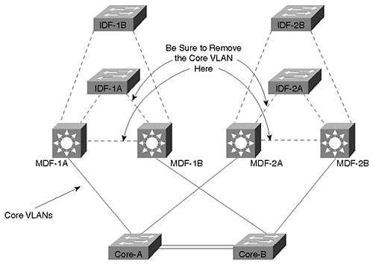
The core in Figure 15-3 is formed by a pair of redundant Layer 2 switches each carrying a single VLAN. All four of the MDF switches connect to one of the core switches (Core-A or Core-B), allowing any single link or switch to fail without creating a permanent outage. If the four MDF switches are configured with Catalyst 8500-style switching routers, then this will automatically result in a loop-free core. On the other hand, the use of Layer 3 router switching (MLS) in the MDF devices requires more careful planning. Specially, the core VLAN must be removed from the links to IDF switches as well as on the link between MDF switches.
Tip
When using MLS (and other forms of routing switches), be certain that you remove the core VLAN from links within the distribution block (the triangles of connectivity formed by MDF and IDF switches).

Larger Layer 2 campus cores require even more careful planning. For example, Figure 15-4 shows a network that covers a larger geographic area and therefore uses four Layer 2 switches within the core. This design is often referred to as a "split Layer 2" core.

Figure 15-4 A Split Layer 2 Core
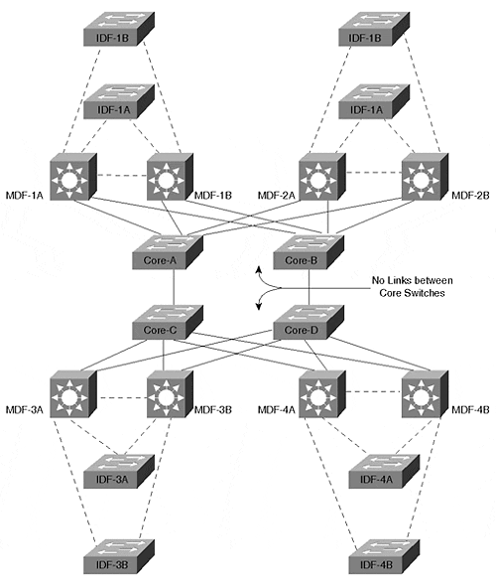
In this case, the key to creating a fast-converging and resilient core is to actually partition the core into two separate VLANs and not cross-link the switches to each other. The first core VLAN is used for the pair of switches on the left, and the second VLAN is used for the pair of switches on the right. If the core switches in Figure 15-4 were cross-linked or fully meshed and a single VLAN were deployed, Spanning Tree convergence and load balancing issues would become a problem.
Finally, notice that creating a loop-free core requires the use of Layer 3 switching in the MDF/distribution layer closets. When using campus-wide VLANs, the only way to achieve a loop-free core is to remove all loops from the entire network, obviously a risky endeavor if you are at all concerned about redundancy. Again, follow the suggestion of this chapter's first section and try to always use the multilayer model and the scalability benefits it achieves through the use of Layer 3 switching.
Tip
When using split Layer 2 cores, some network designers chose to use this to segregate the traffic by protocol to provide additional control. For example, the Core-A and Core-C switches could be used for IP traffic while the Core-B and Core-D can carry IPX traffic. This can be a useful way of guaranteeing a certain amount of bandwidth for each protocol.
It is especially useful when you have non-routable protocols that require bridging throughout a large section of the network. This will allow one half of the core to carry the non-routable/bridged traffic while the other half carries the multiprotocol routed traffic.

This section has repeatedly discussed the pruning of VLANs from links. Obviously, one way to accomplish this is to use the clear trunk command discussed in the "Restricting VLANs on a Trunk" section of Chapter 8. However, the simplest and most effective approach for removing VLANs from a campus core is to just use non-trunk links. By merely assigning these ports to the core VLAN, you will automatically prevent VLANs from spanning the core and creating flat earth VLANs.
Tip
Use non-trunk links in the campus core to avoid campus-wide end-user VLANs.

In fact, this technique is also the most effective method of removing VLAN 1 from the core. Recall that current versions of Catalyst code do not allow you to prune VLAN 1 from Ethernet trunks. Therefore, as discussed earlier, this can result in a single campus-wide VLAN in the all-important VLAN 1 (the last place you want to have loops and broadcast problems).
Tip
Use non-trunk links in the campus core to avoid a campus-wide VLAN in VLAN 1 (this is where you least want a flat earth VLAN, especially if SC0 is assign to VLAN 1).

Don't Forget PLANs
When creating a new design or when your first one or two attempts at solving a particular problem fail, redraw your VLAN design using physical LANs (PLANs). In other words, take the logical topology created through the use of virtual LANs and redraw it using PLANs.
PLAN is a somewhat tongue-in-cheek term the author coined to describe a very serious issue. For some reason, the human brain is almost guaranteed to forget all knowledge of IP subnetting when faced with virtual LANs. People spend days looking at Sniffer traces of complex things like ISL trunks and Spanning Tree to only learn in the end that someone "fat fingered" one digit in an IP address.
So, you ask, what the heck is a PLAN? To answer this mystery, first consider Figure 15-5, a drawing of a typical network using VLANs.

Figure 15-5 Virtual LANs (VLANs)
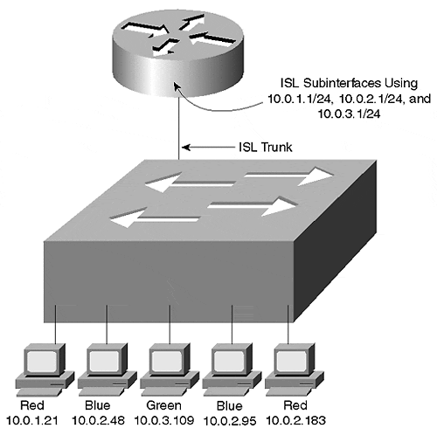
Figure 15-6 redraws Figure 15-5 using PLANs.

Figure 15-6 Physical LANs (PLANs)
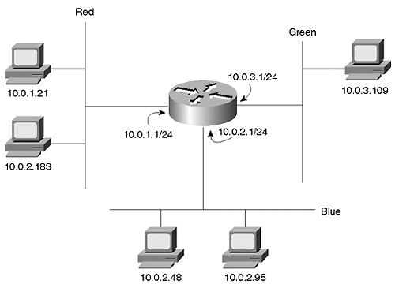
Each VLAN in Figure 15-6 has been redrawn as a separate segment connected to a different router interface. It depicts the logical separation of VLANs with the physical separation used in traditional router and hub designs. However, from a Layer 3 perspective, both networks are identical.
By doing this, it makes the network extremely easy to understand. In fact, it makes it painfully obvious that this network contains a problem—the host using 10.0.2.183 is located on the wrong segment/VLAN (it should be on the Blue VLAN).
Although this might seem like a simple example, simple addressing issues trip up even the best of us from time to time. Why not use a technique that removes VLANs as an extra layer of obfuscation? However, PLANs can be useful in many situations other than for your own troubleshooting. Even if you understand why a network is having a problem, PLANs can be useful for explaining it to other people who might not see the problem as clearly. PLANs can also be used to simplify a new design and help you better analyze the traffic flows and any potential problems.
Tip
PLANs are no joke—use them to help troubleshoot and explain your network.

How to Handle Non-Routable Protocols
Chapter 11 discussed various approaches to integrating Layer 3 routing with Layer 2 bridging, including options such as bridging between VLANs, Concurrent Routing and Bridging (CRB), and Integrated Routing and Bridging (IRB). Most organizations utilize one of these techniques because of the need to have users in two different VLANs communicate via a non-routable protocol such as NetBEUI or LAT. Although the techniques discussed in Chapter 11 can provide relief in limited situations, it is almost always better to avoid their use entirely. Instead, try to place all users of a particular non-routable protocol in a single VLAN. In situations where Catalyst 8500-style switching routers are in use, this might require IRB to be enabled (the Layer 2 nature of MLS does not require the use of IRB).
For more information, see the "Integration Between Routing and Bridging" section of Chapter 11.
Tip
Try to avoid "bridging between VLANs" at all costs.

Spanning Tree
Intertwined with the issue of VLANs is the subject of the Spanning-Tree Protocol. In fact, it is the inappropriate use of VLANs (the flat earth theory) that most often leads to Spanning Tree problems in the first place. This section discusses some of the dos and don'ts of the Spanning-Tree Protocol.
One of the primary themes developed throughout this section is that although Spanning Tree can be quite manageable when used in conjunction with Layer 3 switching, it can also become very complex when used in large, flat designs like campus-wide VLANs. Combining good Spanning Tree knowledge with a good design is the key to success.

Keep Spanning Tree Domains Small
One of the most effective techniques for minimizing Spanning Tree problems is keeping Spanning Tree domains small in size. The easiest way to accomplish this is to use the multilayer design model. By automatically creating Layer 3 barriers that partition the network from a Spanning Tree point of view, most of the typical Spanning Tree problems become non-issues.
There are many benefits to constricting Spanning Tree to small pockets within your network, including the following:
- It allows you to safely tune the Spanning Tree timers.
- As a result, Spanning Tree convergence time can be significantly improved.
- It becomes very difficult for Spanning Tree problems in one section of the network to spread to other sections of the network.
- When using the switching router (Catalyst 8500) form of the multilayer design model, Spanning Tree load balancing can be eliminated. In this case, the IDF traffic creates Layer 2 V's that are inherently loop free and therefore do not require the Spanning-Tree Protocol, although I recommend that you don't disable Spanning Tree; see the next section.
Note
If you enable bridging and/or IRB on Catalyst 8500 devices, they will starting bridging traffic and convert the Layer 2 V's that they produce by default into Layer 2 triangles. This will obviously require the use of Spanning Tree (use of the Root Bridge placement technique discussed in the following bullet point is recommended).

- When using the routing switch (MLS) form of the multilayer design model, Spanning Tree load balancing can be dramatically simplified through the use of the Root Bridge placement technique. When using MLS and the multilayer model, each IDF and a pair of MDFs create Layer 2 triangles that, although not loop free, are easy to manage. For more information on the Root Bridge placement approach to Spanning Tree load balancing, see Chapter 7, "Advanced Spanning Tree," and Chapter 17.
- Spanning Tree becomes much simpler to design, document, and understand.
- Troubleshooting becomes much easier.
Figure 15-7 illustrates the Layer 2 triangles created by MLS (Part A) and the Layer 2 V's created by switching routers. Although MLS very often uses route-switch modules (RSMs), a logical representation has been used for Part A.

Figure 15-7 Layer 2 Topologies under Routing Switches (MLS) and Switching Routers
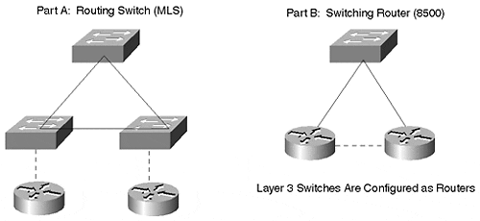
Note
It is important to realize that both routing switches (MLS) and switching routers (8500s) can be used to create the designs shown in Figure 15-7. This section is merely trying to point out the default behavior and most common use of these platforms.

When using campus-wide VLANs, it is often possible to achieve some of the benefits listed in this section by manually pruning VLANs from selected trunks. However, it is not possible to create the simplicity and scalability that are available when using Layer 3 switching. Also, the pruning action can often reduce redundancy in the network.
The multilayer model allows the benefits listed in this section to be easily designed into the network. When using routing switches (MLS) as shown in Part A, this can be accomplished by pruning selected VLANs from key trunk links (such as links in the core and between MDF switches). When using switching routers such as the 8500 as shown in Part B, the benefits of having small Spanning Tree domains accrue by default.

Don't Disable Spanning Tree
In frustration, many organizations disable the Spanning-Tree Protocol to achieve network stability (especially when using flat earth designs). However, when this is done at the expense of redundancy, it obviously introduces a whole new set of problems.
When Spanning Tree is disabled, you are not protected from the inevitable configuration mistakes that create Layer 2 loops in the network. As discussed in Chapter 6, Layer 2 protocols have no way of recovering from feedback loops without a protocol such as Spanning Tree (there is no Time To Live [TTL] field in Layer 2 headers)—the loop continues until you manually intervene.
Typically, Spanning Tree is disabled in one of three situations:
- As a last resort to achieve network stability under the campus-wide VLANs design model—
However, because this also requires that redundancy be eliminated, this is not recommended.
- When using Catalyst 8500-style switching routers in the MDF/distribution layer closets—
Because switching routers result in loop-free Layer 2 V's (as shown in Part B of Figure 15-7), Spanning Tree is no longer required—at least for the intended topology. However, loops can be formed unintentionally through configuration and cabling mistakes on the part of network administrators or because end users installed devices such as hubs or switches. Therefore, an element of risk remains with this approach.
- When using a LANE backbone—
Because LANE automatically creates a loop-free topology within the ATM core itself, Spanning Tree can be disabled. In fact, ATM-centric vendors such as Fore Systems disable Spanning Tree for LANE by default. However, you must be careful to not create Layer 2 loops outside the LANE backbone. Not only does this include the examples discussed in the previous bullet, it also includes such practices as using redundant Ethernet links to extend the ATM backbone to IDF wiring closets.
In general, it is better to use scalable design techniques and Spanning Tree tuning rather than to disable the Spanning-Tree Protocol altogether. As discussed in the previous section, designs such as the multilayer model can achieve network stability without having to resort to disabling Spanning Tree. Also, a carefully planned design can then allow Spanning Tree to be tuned for better performance.

Evaluate Spanning Tree Patterns
As discussed in Chapter 11 and Chapter 14, using Layer 3 switching and the multilayer design model generally results in networks that are comprised of many small "triangles" and "V's" of Layer 2 connectivity.
As this material discussed, switching router platforms such as the Catalyst 8500s produce Layer 2 V's by default. Although bridging and IRB can be enabled to convert these V's into Layer 2 triangles, it is generally advisable to avoid widespread deployment of these features (see the section "Integration between Routing and Bridging" in Chapter 11). Therefore, you will usually see Layer 2 V's in conjunction with switching router technology.
From a Spanning Tree perspective, it is important to note that these V's are loop-free and therefore do not place any ports in the blocking state. As a result, Spanning Tree will not impact your failover performance.
Note
Although Spanning Tree will not impact failover performance of the IDF uplink ports when using Layer 2 Vs, it is still enabled by default and may impact end-user devices. Therefore, you may wish to configure PortFast on end-user ports to facilitate start-up protocols such as DHCP and NetWare authentication.

Unlike 8500s where Layer 2 V's are far more common, MLS (and routing switches) allow you to easily configure either Layer 2 triangles or V's. By default, MLS allows all VLANs to transit the switch. Therefore, assuming that you have removed end-user VLANs from the network core, you will be left with Layer 2 triangles by default (Part A of Figure 15-7). However, by pruning a given VLAN from the link between the MDF/distribution switches, this VLAN can easily be converted into a V (Part B of Figure 15-7). In other words, by simply pruning the VLAN from the triangle's base, it is converted into a V.
From a Spanning Tree perspective, it is important to evaluate the differences that this brings to your network. If you opt for using triangles, then Spanning Tree will be in full effect. The Root Bridge placement form of load balancing and features such as UplinkFast will be important. If you opt for the Layer 2 V's, you will be left with the same "almost Spanning Tree free" situation described several paragraphs earlier in connection with the 8500s.
Tip
Be sure to consider the impact and performance of Spanning Tree where you have Layer 2 triangles in your campus network.

Consider Using Switching Routers to Virtually Eliminate Spanning Tree
Because Catalyst 8500-style switching routers in the MDF/distribution layer closets eliminates loops through the IDF switches, this results in Layer 2 V's. Therefore, Spanning Tree can be much simpler to design, maintain, and troubleshoot. The IDF switch automatically elects itself as the Root Bridge of a one-bridge network (the Layer 3 switches prevent the bridges from learning about each other and keep the Spanning Tree separate). Timer values can be fairly aggressively tuned without risk (use the set spantree root command with a diameter of 2 or 3 hops). Also, Spanning Tree load balancing is no longer necessary.
Note
Note that Layer 2 V's can also be created with routing switch (MLS) platforms by pruning VLAN from selected links (in this case, the base of the triangle—the MDF-to-MDF link).

Consider Using Loop-Free Management VLANs
As discussed in the section "Use Separate Management VLANs," exposing a Layer 2 Catalyst Supervisor to excessive broadcast traffic can lead to network-wide outages. This section recommended using a management VLAN to isolate the Catalyst SC0 interface from end-user broadcast traffic. However, even when using a separate management VLAN, some risk remains. If a loop were to form in the management VLAN itself, the Supervisors could once again find themselves crushed by a wave of traffic.
Tip
Make certain that your design minimizes the risk of braodcast storms occurring in the management VLAN.

Therefore, ensuring that the management VLAN itself is loop free can provide an additional layer of protection. In general, two techniques can be used to create a loop-free management VLAN:
- The use of Catalyst 8500-style switching routers in the MDF/distribution layer automatically creates loop-free management VLANs on the IDF/access devices by default. Notice that this also implies that you should not use IRB to merge the management VLANs back into a single VLAN. Although this can appear to simplify the management of your network by placing all of the switches in a single VLAN, it can create management problems in the long term by adding loops into the management VLAN.
- Campus-wide VLANs often require the use of an out-of-band management network. Because it is very difficult to maintain a loop free and stable environment when campus-wide VLANs are in use, you often have to resort to running separate Ethernet links from routers to a port on each Catalyst. By then assigning only this Ethernet port to the management VLAN used for SC0, a loop-free topology can be created. The ME1 (Management Ethernet) ports available on some Catalyst devices can also be used to create an out-of-band management network.
Figure 15-8 illustrates a typical network using the out-of-band approach to creating loop-free management VLANs. Assume that because the switches are deployed in a haphazard manner, it is not feasible to create loop-free management VLANs using the existing infrastructure. Instead, separate Ethernet links are pulled from the nearest available router port. Where possible, hubs can be used to reduce the number of router ports required.

Figure 15-8 Creating Loop-Free Management VLANs with an Out-Of-Band Network
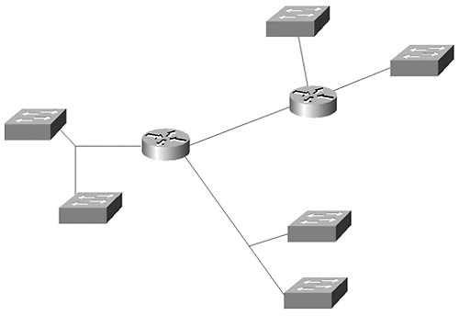
As discussed in the section "Make Layer 2 Cores Loop-Free," you should also keep an eye on VLAN 1. Although you may have carefully used Layer 3 switching to create hierarchy in your network, you can still be left with a campus-wide VLAN in VLAN 1 (especially if you are using MLS Layer 3 switching). Note that this will be true even if you followed the earlier advice (see the section "Prune VLANs from Trunks") of pruning VLANs core VLANs from the wiring closet trunks and wiring closet VLANs from the core trunks (recall that VLAN 1 cannot be deleted and cannot be pruned from Ethernet trunk links in current code images).
Because VLAN 1 is given special priority because of the control traffic discussed in the section "Deciding What Number Should be Used for the Management VLAN," a broadcast loop in this VLAN can be devastating to the health of your network. How, then, are you supposed to control this situation? In general, organizations have used one or more of the following techniques:
- Probably the simplest and most effective option involves using non-trunk links in the core. By assigning each of these core links to a single VLAN (do not use VLAN 1 here!), the core will block the transmission of VLAN 1 information.
Tip
Consider using non-trunk links in the core. This can be an extremely simple but effective way to reduce "Sprawling VLANs" in your network.

- Use "switching routers" such as the Catalyst 8500s that do not forward VLAN 1 by default.
- Once it is available, use the upcoming feature that will allow VLAN 1 to be removed from trunk links (see the section "Deciding What Number Should be Used for the Management VLAN").
- If you are using an ATM core, VLAN 1 can be removed from this portion of the network (see Chapter 9).
Note
For the record, heavy broadcast traffic can also be a problem for routers. They are no different from other devices—all broadcasts must be processed to see if they are "interesting" or not. In fact, this phenomenon can be worse for routers because, by definition, they are connected to multiple subnets and therefore must process the broadcasts from every subnet.
However, with this being said, routers (and Layer 3 switches) are still the best tools for handling broadcast problems. Although the routers themselves can be susceptible to broadcast storms, their very use can greatly reduce the risk of Layer 2 loops ever forming. The multilayer model is designed to maximize this benefit by reducing Layer 2 connectivity to many small triangles and V's. Furthermore, although a broadcast loop can overload any directly-connected routers, the problem does not spread to other sections of the network, a huge improvement over the problems described earlier in this section and in the section "Use Separate Management VLANs."

Always Specify Your Root Bridges
Chapter 6 discussed the problems that can arise when you do not manually specify Root Bridge locations in your network. It is highly possible (even probable if using older Cisco equipment) that a suboptimal bridge or switch wins the Root War election. Rather than leaving it to chance, always specify both a primary and a secondary Root Bridge for every VLAN (in a large and very flat network, it might be beneficial to also specify a tertiary Root Bridge). By manually setting the Root Bridges, it can not only optimize the data path, but it makes the network more deterministic and improves its stability, maintainability, and ease of troubleshooting.
Tip
All networks using groups of contiguous Layer 2 switches or transparent bridges should specify a primary and a backup Root Bridge.

Try to Use Root Bridge Placement Load Balancing
As discussed in Chapter 7, the Root Bridge placement form of Spanning Tree load balancing can be extremely effective and easy to implement if the topology supports it. In most networks that utilize campus-wide VLANs and a centralized server farm, it is very difficult to obtain any degree of load balancing with this technique.
However, when using the multilayer model in conjunction with MLS (and other types of routing switches), this form of load balancing is highly recommended. Because the multilayer model and MLS reduce the network to a series of many small Layer 2 triangles that span each IDF switch and the corresponding pair of MDF switches, the Layer 2 topology is constrained, well-defined, and deterministic. Consequently, it is easy to make one MDF switch the Root Bridge for approximately half of the VLANs contained in that distribution block while the other switch is configured as the Root Bridge for the remaining VLANs. (As a reminder, a distribution block is comprised of a pair of MDF switches and their associated collection of IDF switches—typically this is contained within a single building.) For example, Figure 15-9 illustrates a typical distribution block where MDF-A is the Root Bridge for the odd-numbered VLANs and MDF-B is the Root Bridge for the even-numbered VLANs.

Figure 15-9 Root Bridge Placement Spanning Tree Load Balancing
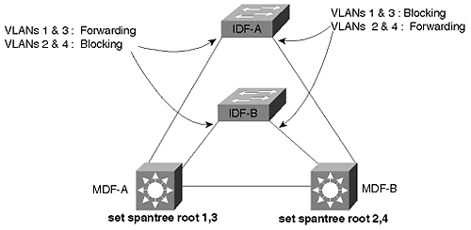
This causes the odd VLANs to use the left riser link (the right IDF port is Blocking for these VLANs), whereas the even VLANs use the right link (the left IDF port is Blocking). As discussed in the following section and Chapter 11, this should be coordinated with any Hot Standby Routing Protocol (HSRP) load balancing being performed by your MDF/distribution layer devices.
Tip
The Root Bridge placement form of Spanning Tree load balancing is both simple and effective.

Root Bridge Placement Considerations
Besides influencing traffic distribution through load balancing, several other factors should be considered when determining where Root Bridges should be located. Some of the more important considerations are mentioned in the following list:
- Place the Root Bridge in the path of high-bandwidth data flows—
This point is discussed in more detail in the following section.
- Use a device that is very stable—
Because Spanning Tree is a protocol that constantly seeks out the most attractive Root Bridge, placing the Root Bridge on a device that reboots or fails frequently can disturb the entire network unnecessarily.
- Use a device that can carry the load—
Because the Root Bridge functions as a central switching node for all of the branches of the Spanning Tree, it must be able to handle the potentially high aggregate load.
When implementing a Spanning Tree design, most organizations adopt one of two strategies:
- Distributed Root Bridges
- Centralized Root Bridges
Distributed Root Bridge placement is useful in situations where network designers want to spread the centralized switching load over more than one bridge. Besides increasing the overall available bandwidth, this technique can also improve network stability by not forcing the entire network to depend on one or two switches for Root Bridge services. However, distributing the Root Bridges can significantly increase troubleshooting complexity in your network by creating a different logical topology for every VLAN.
Tip
In general, distributed Root Bridges can add more complexity to the network than they are worth.

Centralized Root Bridges are useful in situations where the traffic flows are highly concentrated (such as in the case of a centralized server farm). Another advantage of this approach is that it can ease troubleshooting by creating identical (or at least very similar) logical topologies in all VLANs. Overall, centralized Root Bridges are more common.

Where to Put Root Bridges
In general, the most important consideration is placing Root Bridges in the path of high-bandwidth data flows. The goal is to have the Spanning Tree logical topology mirror the natural flow of traffic in your network. To do otherwise implies an inefficient path for the most bandwidth-intensive flows. As discussed in Chapter 6, this optimization is most often achieved in one of two ways:
- When using very flat designs such as campus-wide VLANs, the Root Bridges should generally be placed at the point where the server farm connects to the campus core. Assuming that a pair of switches is used to link the server farm to the core (this provides redundancy as well as additional bandwidth), the Root Bridges can be alternated on a per-VLAN basis.
- When using routing switches (MLS) with the multilayer model, the Root Bridge should be located in the switch that contains (or, in the case of an external router, links to) the active HSRP peer for a given VLAN. Therefore, if an MDF switch is acting as the active HSRP peer for the odd-numbered VLANs, it should also be the primary Root Bridge for these VLANs.

Timer Tuning
Your decision to utilize Spanning Tree timer tuning should be based primarily on your campus architecture. If you have utilized the campus-wide VLAN model, timer tuning is almost always an exercise in futility and frustration. Because campus-wide VLANs lead to very large Spanning Tree domains, timer tuning usually results in a network plagued by instability.
Tip
Do not attempt Spanning Tree timer tuning if your network uses the campus-wide VLAN model.

On the other hand, the Layer 3 barriers created by the multilayer model make timer tuning a very attractive option for most networks. When performing timer tuning, it is usually best to use the set spantree root macro discussed in the "Using A Macro: set spantree root" section of Chapter 6. In general, the values in Table 15-1 have been shown to be a good compromise between network stability and speed of convergence (for more information on the details of these timer values, refer to Chapters 6 and 7).

Table 15-1. Recommended Spanning Tree Timer Values
Network Design | Specified Diameter | Specified Hello Time | Resulting Max Age | Resulting Forward Delay
Campus-wide VLANs | N/A | N/A | Default (20 secs) | Default (15 secs)
Multilayer and routing switches (MLS) | 3 hops | 2 secs | 12 secs | 9 secs
Multilayer and switching routers (8500s) | 2 hops | 2 secs | 10 secs | 7 secs
Because timer tuning is not recommended for campus-wide VLANs and should therefore not be specified on the set spantree root command, these values have been omitted from Table 15-1. (Although, as discussed in Chapter 7, 802.1D assumes a diameter of 7 hops and the Hello Time defaults to 2 seconds.) The routing switch (MLS) and switching router values are based on fairly conservative assumptions about link failures and the possibility of additional bridging devices being attached to the network (these values are also used and discussed in the case studies covered in Chapter 17).
Also, if you are willing and able to incur the extra load of Spanning Tree BPDUs, the Hello Time can be reduced to 1 second to further improve convergence times. However, notice that this doubles the bandwidth consumed by BPDUs, and, more importantly, the load on the supervisor CPUs. Therefore, if each device only participates in a small number of VLANs, Hello tuning can successfully improve Spanning Tree convergence times with minimal impact on the CPU. Conversely, if your devices participate in a large number of VLANs, changing the Hello Time can overload your CPUs. When using a large number of VLANs, only lower the Hello Time for a subset of the VLANs where you need the improved convergence time as a compromise. If lowering the Hello Time to one second, consider using the values specified in Table 15-2.

Table 15-2. Spanning Tree Timer Values When Using a Hello Time of 1 Second
Network Design | Specified Diameter | Specified Hello Time | Resulting Max Age | Resulting Forward Delay
Multilayer and routing switches (MLS) | 3 hops | 1 secs | 7 secs | 5 secs
Multilayer and switching routers (8500s) | 2 hops | 1 secs | 5 secs | 4 secs
Finally, be certain that you set the chosen timer values on both the primary and backup Root Bridges. You can set the values on other bridges/switches, but it has no effect (for simplicity, some organizations simply set the values on every device).

Spanning Tree and the Management VLAN
The point made earlier in the "Consider Using Loop-Free Management VLANs" section bears repeating—Layer 2 loops in the management VLAN can lead to catastrophic network failures. You should consider implementing loop-free VLANs for your management networks, especially if using a flat earth network topology.

Study Your Spanning Tree Logical Topology
The time to be learning your Spanning Tree logical topology is not during the middle of a major network outage. Instead, it is advisable to create maps of both your primary and backup Spanning Tree topologies beforehand. Most organizations are accustomed to making extensive use of diagrams that reveal the Layer 3 topology of their network (often using tools such as HP OpenView). However, very few of these same organizations go through the exercise of creating and distributing Layer 2 maps.
Tip
A picture is worth a thousand words… diagram your Layer 2 topologies (including Spanning Tree).

At a minimum, these diagrams should illustrate the extent of each VLAN, the location of the Root Bridge, and which switch-to-switch ports are Blocking or Forwarding (diagramming end-user ports is rarely beneficial). In addition, it might be useful to label the Forwarding ports as either Designated Ports or Root Ports. See Chapters 6 and 7 for more information on these ports.
Tip
CiscoWorks 2000 can create basic Spanning Tree maps.

The importance of having Layer 2 diagrams is influenced by, once again, the choice of the network's design. They are especially important in the case of campus-wide VLANs where the combination of many VLANs and Blocking/Forwarding ports can become very complex. Fortunately, another benefit of the multilayer model is that it reduces the need for diagrams. First, the Layer 3 hierarchy created by this design makes the traditional Layer 3 maps much more useful. Second, the simplistic Layer 2 triangles and V's created by this design allow two or three template drawings to be used to document the entire Layer 2 network.

When to Use UplinkFast and BackboneFast
Both UplinkFast and BackboneFast are significant Cisco enhancements to the Spanning-Tree Protocol. It is important to know when and when not to use them. In general, neither feature is particularly useful in a network that contains a very strong Layer 3 switching component. Because this tends to break the network into a large number of loop-free paths, there are no Blocking ports for UplinkFast and BackboneFast to perform their magic.
Tip
Don't waste your time designing lots of Spanning Tree optimizations (such as UplinkFast and BackboneFast) into a heavily Layer 3-oriented network—they will have little or no effect.

On the other hand, UplinkFast and BackboneFast can be extremely useful in more Layer 2-oriented designs such as campus-wide VLANs and the multilayer model with routing switches (MLS). In either case, UplinkFast should be enabled only on IDF wiring closet switches while BackboneFast is enabled on every switch in each Spanning Tree domain. It is important to follow these guidelines. Although both protocols have been carefully engineered to not completely disable the network when they are used incorrectly, it causes the feature to either be completely ineffective (as is possible with BackboneFast) or to invalidate load balancing and Root Bridge placement (as is possible with UplinkFast). See Chapter 7 for more detailed information on BackboneFast and UplinkFast.

When to Use PortFast
PortFast is a tool that deserves consideration in every network. There are two main benefits to using PortFast:
- End stations and some servers that use fault-tolerant NICs can gain immediate access to the network. In the case of end stations, this can help with protocols such as DHCP and initial server or directory authentication. For servers using fault-tolerant NICs that toggle link-state, PortFast can mean the difference between transparent failover and a 30–50 second outage (however, most fault-tolerant NICs do not toggle link). When using PortFast with server connections, be sure to disable PAgP on EtherChannel-capable ports. Otherwise PortFast still takes approximately 20 seconds to enable the link. For more information, please refer to the section "Disabling Port Aggregation Protocol" in Chapter 7.
- Ports do not send Topology Change Notification (TCN) BPDUs when they are using PortFast. Because TCNs cause bridges and switches to use a shorter bridge aging period, an excess of these packets can destabilize a large campus network (especially with flat earth designs like campus-wide VLANs). By potentially eliminating tens of thousands of TCNs per day in the typical large campus network, the use of PortFast can have a significant impact.
Even though Catalysts allow you to enter the set spantree portfast mod_num/port_num enable command on a trunk link, the command is ignored. Despite this feature, it is best to leave PortFast disabled on trunk links and spare other administrators of the network some confusion when they see it enabled.
Tip
Although PortFast is extremely useful in Ethernet-only networks, you might wish to avoid its use in networks that employ a LANE core. Because PortFast suppresses TCN BPDUs, it can interfere with LANE's process of learning about devices/MAC addresses that have been relocated to a different LANE-attached switch. As a result, nodes that relocate may have to wait five minutes (by default) for their connectivity to be re-established if PortFast is in use.
By disabling PortFast, LANE will receive a TCN (both when the node is initially disconnected from the original switch and when it is reconnected to the new switch) that shortens the MAC aging process to the Spanning Tree Forward Delay timer (see Chapter 6). As an alternative you can manually (and permanently) lower the bridge table aging period using the set cam agingtime command. Both techniques will cause LANE to remove the MAC address to NSAP address mapping in the LES more quickly and force it to relearn the new mapping for a device that has been relocated. See Chapter 7 for more detailed information on the operation of LANE.

When One Spanning Tree Is Not Enough
Although many people complain that one Spanning Tree per VLAN is too complex for human comprehension (by the way, this is an exaggeration), there are times when you actually want to use more than one Spanning Tree per VLAN! Other than the corner-case of using PVST+ to tunnel multiple Spanning Trees through an 802.1Q region that only utilizes a single Spanning Tree, the primary use of multiple Spanning Trees per VLAN is to successfully integrate bridging and routing between VLANs. (See the "Per-VLAN Spanning Tree Plus" section of Chapter 7 for more information on PVST+). When combining bridging and routing, the situation can arise where IP subnets become partitioned and a partial loss of connectivity occurs—for example, when bridging protocols such as NetBIOS and LAT while simultaneously routing traffic such as IP. Chapter 11 referred to this as the broken subnet problem in the "Issues and Caveats with Bridging between VLANS" section and the "How to Fix the Broken Subnet Problem" section.
Tip
Watch out for the "broken subnet problem." It can create difficult to troubleshoot connectivity problems.

As detailed in Chapter 11, the solution is to use two versions of the Spanning-Tree Protocol. The Layer 2 Catalysts such as the 5000 and the 6000 only use the IEEE version of the Spanning-Tree Protocol. However, IOS-based devices such as the routers and Catalyst 8500s can either run the DEC version of Spanning Tree-Protocol or Cisco's proprietary VLAN-Bridge Spanning-Tree Protocol. In both cases, the BPDUs for these two protocols are treated as normal multicast data by the Layer 2 Catalysts and flooded normally. Conversely, the IOS-based devices swallow the IEEE BPDUs when they are running a different version of the Spanning-Tree Protocol. Consequently, the IOS-based devices partition the IEEE protocol into smaller pockets. Within each pocket, the IEEE Spanning-Tree Protocol ensures that the logical topology is loop free. The DEC or VLAN-Bridge version of the Spanning-Tree Protocol ensures that the collection of pockets remains loop free. The result is a network where both routed and non-routed protocols have full connectivity throughout the network. For more information, see the "Using Different Spanning-Tree Protocols" section in Chapter 11.

Load Balancing
Load balancing can be one of the telltale signs that indicate whether a network has been carefully planned or if it has grown up like weeds. By allowing redundant links to effectively double the available bandwidth, load balancing is something that every network should strive to implement.
This chapter briefly mentions the most popular alternatives available for implementing load balancing. As you go through this section, recognize that none of these accomplish round robin or per-packet load balancing. Therefore, although these techniques are most often referred to with the name load balancing, the name load sharing or load distribution might be more appropriate. However, do not get hung up with trying to achieve an exact 50/50 split when you implement load balancing over a pair of links. Just remember that any form of load balancing is preferable to the default operation of most campus protocols where only a single path is ever used.

Remember the Requirements for Load Balancing
Before diving into the details of various approaches to load balancing, it is worth pausing to examine some high-level considerations of load balancing. When thinking about load balancing, first look at the number of available paths. If you have only one set of paths through your network, load balancing (and, therefore, redundancy) is not possible. Most network designers strive to achieve two paths, as typically seen connected to an IDF/access layer switch. In some cases, especially inside a large campus core, more than two paths might be available.
Another consideration is the ease with which you can configure, manage, and troubleshoot a particular load balancing scheme. For example, the Root Bridge placement form of Spanning Tree load balancing is very easy to implement and troubleshoot.
Also, look at the flexibility of each style of load balancing. For instance, although Root Bridge placement scores very high on the simplicity scale, it can only be implemented in selected topologies (such as the Layer 2 triangles used by the multilayer model). By way of contrast, the portvlancost method of Spanning Tree load balancing is very flexible (however, it is also more complex).
Finally, consider the intelligence of a load balancing scheme. For example, some techniques such as EtherChannel use a very simple XOR algorithm on the low-order bits of IP or MAC address. On the other hand, Layer 3 routing protocols offer very sophisticated and tunable load balancing and, more importantly, path selection tools.
Tip
Important load balancing considerations include:
- Available paths
- Ease of configuration, management, and troubleshooting
- Flexibility
- Intelligence

Spanning Tree
Spanning Tree load balancing is useful within a redundant Layer 2 domain. As discussed in Chapter 7, there are four techniques available for load balancing under the Spanning-Tree Protocol:
- Root Bridge placement
- Port priority (portvlanpri)
- Bridge priority
- Port cost (portvlancost)
As discussed in Chapter 7 and earlier in this chapter, Root Bridge placement is the simplest and most effective technique if the network's traffic flows support it. Fortunately, the multilayer model with routing switches (MLS) automatically generates a topology where the Root Bridges can be alternated between redundant MDF switches within a distribution block.
Tip
When working with the Spanning-Tree Protocol, try not to use the Root Bridge placement form of Spanning Tree load balancing.

Root Bridge placement is not effective in less constrained topologies such as campus-wide VLANs. In these cases, it is best to use the portvlancost form of load balancing. Although portvlancost is harder to use than Root Bridge placement, it is useful in almost any redundant topology. Think of it as the Swiss army knife of Spanning Tree load balancing.
Tip
When working with the Spanning-Tree Protocol, use portvlancost load balancing when the use of Root Bridge placement is not possible.

HSRP
In situations where Layer 3 switching is being used, HSRP plays an important role. When using Layer 3 switching in networks that contain Layer 2 loops in the distribution block, such as with the multilayer model and routing switches (MLS), Spanning Tree and HSRP load balancing should be deployed in a coordinated fashion. For example, the network in Figure 15-9 modified the Spanning Tree parameters to force the odd VLANs to use the left link and the even VLANs to use the right link. HSRP should be added to this design by making MDF-A the active HSRP peer for the odd VLANs and MDF-B the active peer for the even VLANs.
Tip
Be sure to coordinate HSRP and Spanning Tree load balancing. This is usually required in networks employing routing switches and the multilayer model.

In cases where the switching router (8500) approach to the multilayer model is in use, HSRP might be the only option available for load balancing within each distribution block (there are no loops for Spanning Tree to be effective). Consequently, two HSRP groups should be used for each subnet. This configuration was discussed in Chapter 11 and is referred to as Multigroup HSRP (MHSRP). MHSRP can be used to load balance by alternating the HSRP priority values.
Tip
Use MHSRP load balancing for networks using switching router technology.

Figure 15-10 illustrates an example that provides load balancing for one subnet/VLAN on an IDF switch.

Figure 15-10 MHSRP Load Balancing
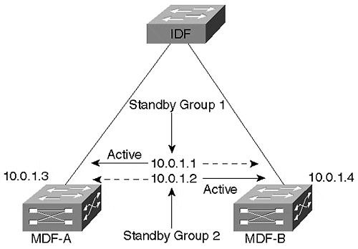
Both of the MDF switches are assigned two real IP addresses, 10.0.1.3 and 10.0.1.4. Rather than using a single standby group (which results in only one router and one riser link actively carrying traffic), two standby groups are configured. The first standby group uses an IP address of 10.0.1.1 and the priority of MDF-A has been increased to make it the active peer. The second standby group uses 10.0.1.2 and has MDF-B configured as the active peer. If both MDF switches are active, both riser links and both devices actively carry traffic. If either MDF device fails, the other MDF takes over with 100 percent of the load.

IP Routing
Another advantage in using Layer 3 switching is that IP routing protocols support very intelligent forwarding and path determination mechanisms. Whereas it can take considerable configuration to enable load balancing over two paths using techniques such as Spanning Tree load balancing and HSRP, Cisco routers automatically load balance up to six equal-cost paths (although Catalyst 8500s currently only load balance over two equal-cost paths because of the microcode memory limitations). Moreover, Layer 3 routing protocols support extensive path manipulation tools such as distribute lists and route maps.
Given that the multilayer design model focuses on Layer 3 switching in the MDF/distribution layer closets (and possibly the core), IP routing can be an extremely effective approach to load balancing across critical areas of the network such as the core (expensive WAN links are another area).

ATM
One of the benefits in using ATM in a campus environment is the sophistication of Private Network-Network Interface (PNNI) as an ATM routing and signaling protocol. Like IP, PNNI automatically load balances traffic over multiple paths. However, unlike IP, PNNI does not perform routing on every unit of information that it receives (cells). Instead, ATM only routes the initial call setup that is used to build the ATM connection. After the connection has been established, all remaining cells follow this single path. However, other calls between the same two ATM switches can use a different set of paths through a redundant ATM network (therefore, PNNI is said to do per connection load balancing). In this way, all of the paths within the ATM cloud are automatically utilized.
For more information on ATM, LANE, and PNNI, please consult Chapter 9, "Trunking with LAN Emulation."

EtherChannel
A final form of load balancing that can be useful for campus networks is EtherChannel. EtherChannel can only be used between a pair of back-to-back switches connected between two and eight links (although some platforms allow limited combinations). It uses an XOR algorithm on the low-order bits of MAC or IP addresses to assign frames to individual links. For more information, see Chapter 8, "Trunking Technologies and Applications."
Tip
The 802.3ad committee of the IEEE is working on a standards-based protocol similar to Cisco's EtherChannel.

Routing/Layer 3 Switching
As this chapter has already mentioned many times, Layer 3 switching is a key ingredient in most successful large campus networks. This section elaborates on some issues specific to Layer 3 switching.

Strive for Modularity
One of the primary benefits of using Layer 3 technology is that it can create a high degree of modularity in a design. For instance, Figure 15-11 illustrates a typical two-building campus using the multilayer model.

Figure 15-11 Using a Layer 3 Barrier to Create a Modular Design
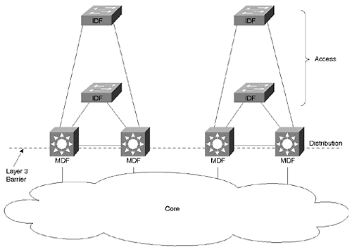
The Layer 3 barrier created by the routing function embedded in the MDF switches separates each building from the core. The primary benefits of this technique are:
- The modularity allows for cookie-cutter designs. Although the IP addresses (as well as other Layer 3 protocol addresses) change, each distribution block can be implemented with almost identical switch and router code.
- The network is very easy to understand and troubleshoot. Technicians can apply most of the same skills used for managing and troubleshooting router and hub networks.
- The network is highly scalable. As new buildings or server farms are added to the campus, they merely become new distribution blocks off the core.
- The network is very deterministic. As devices or links fail, the traffic will failover in clearly defined ways.
Although some degree of modularity can be created with more Layer 2-oriented designs such as campus-wide VLANs, it is much more difficult to get the separation required for true modularity. Without a Layer 3 barrier of scalability, the Layer 2 protocols tend to become intertwined and tightly coupled. Consequently, it becomes more difficult to grow and rearrange the network.

When to Use MLS (and Routing Switches)
The routing switch (MLS) form of the multilayer model is most appropriate when you want to maintain a strong Layer 2 component within each distribution block. By doing so, MLS allows the feature-rich Layer 2 Catalysts to flourish. Options such as VTP and PVST can all be very useful in this environment. Also, by maintaining this strong Layer 2 orientation, you can easily place a single VLAN on multiple IDF/access layer wiring closets (8500s require bridging/IRB to accomplish this). Furthermore, MLS has excellent support for multiprotocol routing, as well as combining routing and bridging within the same device. For more information on the specific benefits and configuration commands for MLS, see Chapter 11, Chapter 14, and Chapter 17.

When to Use Switching Routers (8500s)
Whereas MLS maintains a Layer 2 flavor within the distribution block, switching routers go to the opposite extreme. Switching routers such as the Catalyst 8540 are most easily configured and maintained when functioning as a pure router. Although they do support bridging through the use of IRB and bridge groups, extensive use of these features can lead to configurations that are difficult to maintain.
Instead, by using these devices as very high-speed routers, they can dramatically simplify network design. Issues and problems associated with Spanning Tree all but disappear. Traffic flows become highly deterministic. Support personnel accustomed to working in the traditional router and hub model find switching router designs easy to support and troubleshoot. The superior support of IP multicast technology at Layer 3 provides an excellent migration path to the future.
As with MLS, more information can be found on the pros and cons of switching routers in Chapters 11, 14, and 17.

When to Use IRB
In short, use IRB only when you have to. It is not that IRB is a bad feature. In fact, IRB is a very flexible technology for combining Layer 2 and Layer 3 traffic and it allows precise control over how both bridged and routed traffic is handled. The problem is more likely to be a human one—IRB can be difficult to understand, support, and design.
When considering the use of IRB, also take into account the following issues:
- An advantage to doing IRB on hardware-based platforms such as the Catalyst 8500 is that it can be performed at wire speed (the software-based routers are currently limited to fast-switching speeds).
- There is a limit to the number of Bridged Virtual Interfaces (BVIs) that the IOS supports (currently 64).
- Some features are not supported on BVIs. Because the list is constantly changing, check the release notes or place a call to Cisco's TAC.
When deciding where to utilize IRB, try to use it only as a tool for specific niche issues—for example, if you need to place several directly-connected servers into a single VLAN or if there is a VLAN that absolutely must transit a switching router.
Tip
If your design calls for the extensive use of IRB, consider using the Catalyst 6000 "Native IOS Mode" detailed in Chapter 18. In general, it will result in a network that is considerably easier to configure and maintain.

Limit Unnecessary Router Peering
When using routers in VLAN-based networks, it can be important to reduce unnecessary router peering. For example, consider cases such as those illustrated in Figure 15-7 and Figure 15-10. Assume that these routers connect to 30 wiring closet VLANs via ISL or 802.1Q trunks. By default, the routers will form 30 separate adjacencies, wasting valuable router memory and processor power. By listing all or most of these VLANs as passive interfaces for the routing protocol, this can dramatically reduce this unnecessary peering. For wiring closet VLANs where no other routers are located, all VLANs should be removed.
Tip
Reducing unnecessary peering can be especially important with Catalyst 8500 routers and the Catalyst 6000 MSM.

Load Balancing
As discussed in the Spanning Tree sections, the style of load balancing that is needed depends primarily on the type of Layer 3 switching that is in use. To summarize the earlier discussion, MLS generally requires that a combination of Spanning Tree and HSRP load balancing techniques be used within the distribution block. When using switching routers, MHSRP should be used.
Also, Layer 3 switches automatically load balance across the campus core if equal-cost paths are available.

Try to Use Only Routable Protocols
Unless it is absolutely necessary, try to pass only routable protocols through your Layer 3 switches. This is most often accomplished by relegating non-routable protocols to a single VLAN. If you are migrating to a new network infrastructure, consider leaving the non-routable traffic on the old infrastructure. The lagging performance of that network serves as an incentive for users of non-routable protocols to upgrade to an IP-based application.

ATM
As Layer 3 switching has grown in popularity, it has demonstrated that ATM is not the only technology capable of great speed. However, ATM does have its place in many campus networks. This section examines some of the more important issues associated with completing an ATM-based campus network design.

When to Use ATM
One of the first questions every network designer must face is should the design utilize ATM technology. In the past, ATM has been billed as the solution to every possible network problem. Although this might be true in terms of ATM's theoretical capabilities, it is not true in terms of how most organizations are using ATM. For example, in the mid-1990s, many network analysts foretold of the coming days where networks would use ATM on an end-to-end basis. Instead, Ethernet has continued to grow in popularity. When, then, is it best to use cell-based switching?
Traditionally, ATM has been touted for several unique benefits. The most commonly mentioned benefits include:
- High bandwidth—
Because cells use fixed-size units of data with simple and predictable header formats, it is fairly easy to create high-speed hardware-based switching equipment.
- Sophisticated bandwidth sharing—
Cells can be interleaved to allow multiple communication sessions to share a single link through an advanced form of statistical multiplexing. Because cells are all the same size, applications using large data transfer units do not create a log jam effect that slows down smaller and potentially more time-sensitive traffic.
- Quality of Service (QoS)—
ATM has complex and sophisticated mechanisms to allow detailed traffic contracts to be specified and enforced.
- Support for voice and video—
ATM's low latency and QoS benefit give it robust support for time-critical forms of communication such as voice and video.
- Distance—
Unlike common campus technologies such as Ethernet, ATM can function over any distance.
- Interoperability—
Because ATM is a global standard, a wide variety of devices can be purchased from different vendors.
Although many of these points remain true, advances in frame-based switching have significantly eroded ATMs edge in the following areas:
- Campus-oriented Gigabit Ethernet switches now match or exceed the speed of ATM switches. Although cell switching does maintain a theoretical advantage, ASIC-based Layer 2 and Layer 3 switches have become exceptionally fast. Furthermore, ATM has continued to struggle with the SAR boundary, the fastest speed that ATM's Segmentation And Reassembly function can be performed.
- Ethernet-based QoS (or at least Class of Service) schemes are becoming more available, more practical, and more effective. Although ATM holds a theoretical lead, ATM continues to suffer from a lack of applications that capitalize on its inherently superior capabilities. As a result, CoS-capable Gigabit Ethernet switches are rapidly growing in popularity.
- Although ATM does maintain a distinct advantage in its capability to handle isochronous (timing critical) applications, there is tremendous growth in non-isochronous mechanisms for sending voice and video traffic. Efforts such as voice over IP (VoIP) and H.323 videoconferencing are common examples. These technologies reduce the need for ATM's unique capabilities.
- Gigabit Ethernet distances are growing dramatically. As this book goes to press, a number of vendors are introducing 80–100 km Gigabit Ethernet products.
- All forms of Ethernet, including Gigabit Ethernet, have been perceived as being considerably more interoperable than ATM standards.
In addition, the complexity of ATM has become a significant issue for most organizations. Whereas Ethernet is considered easy and familiar, ATM is considered difficult and murky (and, to a significant extent, these perceptions are valid).
Tip
Although the growth of ATM in campus networks has slowed at the time this book goes to press, it is important to note that the use of ATM technology in the WAN continues to expand rapidly.

Where to Use ATM
Although there is considerable debate about the usefulness of ATM in a campus backbone, there is considerably less debate about where it is useful. Almost all analysts are in agreement that desktop connections will be Ethernet for the foreseeable future. Although 10/100 Ethernet sales continue to soar, sales of ATM to the desktop have staggered. When ATM is used, almost all agree that the ATM is best suited to the core of the network. In most cases, this means a LANE core connecting to Ethernet switches containing LANE uplink modules.
Although this issue has received fairly little debate, a second issue has been less clear-cut. The issue concerns the matter of how far the ATM backbone should reach. The debate surrounds two options.
Some vendors and network designers prefer to link only the MDF/distribution layer devices to the ATM core. Fast and Gigabit Ethernet links can then be used to connect to IDF switches as shown in Figure 15-12.

Figure 15-12 Using Ethernet Links in Conjunction with an ATM Core
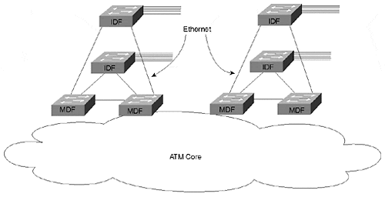
The advantage of this approach is that it uses cost-effective Ethernet technology in the potentially large number of IDF closets. This design is often deployed using the campus-wide VLAN model to extend the speed of ATM through the Ethernet links. The downside is that it creates a large number of Layer 2 loops where redundant MDF-to-IDF links are used. Unfortunately, these links have been shown to create Spanning Tree loops that can disable the entire campus network. Furthermore, it is harder to use ATM features such as QoS when the edges of the network use Ethernet.
The opposing view is that the ATM backbone should extend all the way to the IDF closets. Under this design, the entire network utilizes ATM except for the links that directly connect to end-user devices. This approach is illustrated in Figure 15-13.

Figure 15-13 Extending the ATM Core to the IDF Switches
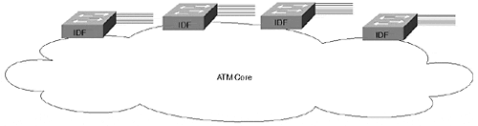
The downside of this alternative is a potentially higher cost because it requires more ATM uplink and switch ports. However, the major benefit of this design is that it eliminates the Layer 2 loops formed by the Ethernet links in the previous approach. Because LANE inherently creates a loop-free Layer 2 topology, the risk of Spanning Tree problems is considerably less (in fact, some vendors who promote this design leave Spanning Tree disabled by default, something many network engineers feel is a risky move).
Having worked with implementations using both designs, I feel that the answer should be driven by the use of Layer 3 switching (like many other things). If you are using the multilayer model to create hard Layer 3 barriers in the MDF/distribution layer devices, the MDF switches can be the attachment point to the ATM core and Ethernet links to the IDF devices can be safely used. However, when the campus-wide VLAN model is in use, extending the ATM backbone to the IDFs allows for the most stable and scalable design. Trying to use the MDF-attachment method with campus-wide VLANs results in Spanning Tree loops and network stability issues.
Tip
The use of Layer 3 switching in your network should drive the design of an ATM core.

Using SSRP
Until standards-based LANE redundancy mechanisms become widely available, Simple Server Redundancy Protocol (SSRP) will remain an important feature in almost any LANE-based core using Cisco ATM switches. Although SSRP allows more than one set of redundant devices, experience has shown that this can lead to scaling problems. See Chapter 9 for more information on SSRP.

BUS Placement
Always try to place your LANE Broadcast and Unknown Server (BUS) on a Catalyst LANE module. Because the BUS must handle every broadcast and multicast packet in the ELAN (at least in current versions of the protocols), the potential traffic volume can be extremely high. The Catalyst 5000 OC-3 and Catalyst 5000/6000 OC-12 LANE modules offer approximately 130 kpps and 450 kpps of BUS performance respectively, considerably more than any other Cisco device currently offered.
One decision faced by designers of large LANE cores involves whether a single BUS or multiple distributed BUSes should be utilized. The advantage of a single BUS is that every ELAN has the same logical topology (at least the primary topologies are the same, the backup SSRP topology is obviously different). The disadvantage is that the single BUS can more easily become a bottleneck.
Distributed BUSes allow each ELAN to have a different BUS. Although this can offer significantly higher aggregate BUS throughput, it can make the network harder to manage and troubleshoot. With the introduction of OC-12 LANE modules and their extremely high BUS performance, it is generally advisable to use a single BUS and capitalize on the simplicity of having a single logical topology for every ELAN.
Tip
With the high BUS throughput available with modern equipment, centralized BUS designs are most common today.

Chapter 9 contains additional information on BUS placement.

MPOA
Multiprotocol Over ATM (MPOA) can be a useful technology for improving Layer 3 performance. MPOA, as discussed in Chapter 10, "Trunking with Multiprotocol over ATM," allows shortcut virtual circuits to be created and avoids the use of routers for extended flows. When considering the use of MPOA, keep the following points in mind:
- MPOA can only create shortcuts in sections of the network that use ATM. Therefore, if the MDF devices attach to an ATM core but Ethernet is used to connect from the MDF to the IDF switches, MPOA is only useful within the core itself. If the core does not contain Layer 3 hops, MPOA offers no advantage over LANE. In general, MPOA is most useful when the ATM cloud extends to the IDF/access layer switches.
- Because MPOA is mainly designed for networks using ATM on an IDF-to-IDF basis, you must intentionally build Layer 3 barriers into the network. Without careful planning, MPOA can lead to flat earth networks and the associated scaling problems discussed earlier in this chapter and in Chapters 11, 14, and 17.
- At presstime, significant questions remain about the stability and scalability of MPOA.
Tip
MPOA only optimizes unicast traffic (however, related protocols such as a MARS can be used to improve multicast performance).

Hardware Changes
In most Catalyst equipment (such as the Catalyst 5000), both MPOA and LANE use MAC addresses from the chassis or Supervisor to automatically generate ATM NSAP addresses. For a detailed discussion of how NSAP addresses are created, refer to Chapter 9. When designing an ATM network, keep the following address-related points in mind:
- Devices with active backplanes such as the Catalyst 5500s use MAC addresses pulled from the backplane itself. Changing the chassis of one of these devices therefore changes the automatically-generated NSAP addresses.
- Devices with passive backplanes such as the Catalyst 5000 use MAC addresses from the Supervisor. Therefore, changing a Catalyst 5000 Supervisor module changes the pool of addresses used for automatically generating NSAP addresses.
- In both cases, 16 MAC addresses are assigned to each slot. Therefore, simply moving a LANE module to a different slot alters the automatically generated NSAP addresses.
- Because of these concerns, many organizations prefer to use hard-coded NSAP addresses. For more information, see the section "Using Hard-Coded Addresses" in Chapter 9.
Tip
Consider using hard-coded NSAP addresses in a large LANE network.

Campus Migrations
It can be very challenging to manage a campus migration. New devices are brought online as older equipment is decommissioned or redeployed. However, while the rollout is taking place, connectivity must be maintained between the two portions of the network. This section makes a few high-level recommendations.

Use the Overlay Approach
During a migration, many organizations attempt to intermingle old and new equipment on the same links to form a single network. Although this does appear appealing from the perspective of trying to maintain full connectivity during the migration, it can make the rollout extremely difficult. By intermingling the two sets of equipment, the new network can be dragged down by the old equipment. Problems such as excessive bridging for non-routable protocols and Spanning Tree issues can prevent the new network from living up to its full potential. Moreover, if two Gigabit-speed switches are forced to communicate through an existing software-based router, it is like trying to drive a 6000 hp dragster down a dirt road!
In general, the most effective solution for dealing with campus migrations is to use the overlay technique.
As shown in Figure 15-14, the overlay approach treats the two networks as totally separate. Rather than connecting the new devices to the existing links, a completely out-of-band set of new links are used. If old and new devices are located in the same wiring closet, both connect to separate links. Therefore, the new network is said to overlay the existing network.

Figure 15-14 The Overlay Approach to Campus Migrations
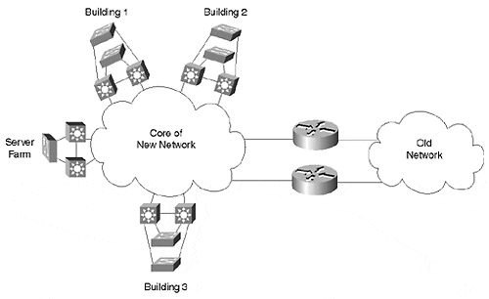
To maintain connectivity between the old and the new network, a pair of redundant routers is used. This provides a single line where the two networks meet. Issues such as route redistribution and access lists can be easily handled here. Also notice that this causes the old network to resemble just another distribution block connected to the core of the new network (another benefit of the modularity created by the multilayer model).

Server Farms
Servers play a critical role in modern networks. Given this importance, they should be considered early in the design process. This section discusses some common issues associated with server farm design.

Where to Place Servers
Most organizations are moving toward centralized server farms to allow better support and management of the servers themselves. Given this trend, it is generally best to position a centralized server farm as another distribution block attached to the campus core. This concept is illustrated in Figure 15-15.

Figure 15-15 Centralized Server Farm
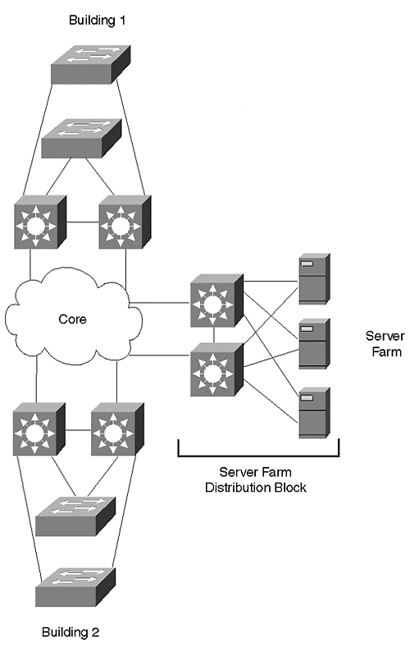
The servers in Figure 15-15 can be connected by a variety of means. The figure shows the servers directly connected to the pair of Layer 3 switches that link to the campus core. An alternative design is to use one or more Layer 2 switches within the server farm. These Layer 2 devices can then be connected to the Layer 3 switches through Gigabit Ethernet or Gigabit EtherChannel. Although some servers can connect to only a single switch, redundant NICs provide a measure of fault-tolerance.
The key to this design is the Layer 3 barrier created by the pair of Layer 3 switches that link the server farm to the core. Not only does this insulate the server farm from the core, but it also creates a much more modular design.
Some network designs directly connect the servers to the core as shown in Figure 15-16.

Figure 15-16 Connecting Servers Directly to the Campus Core
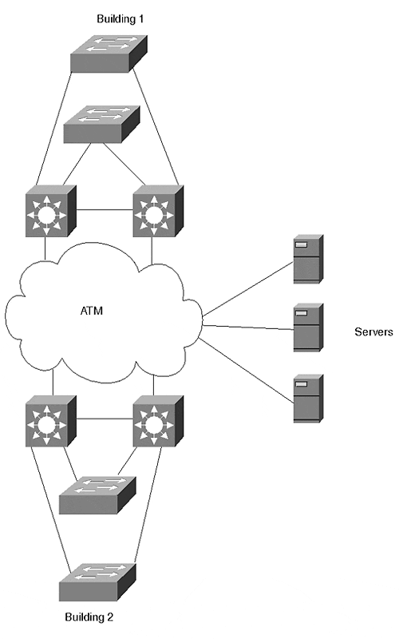
Figure 15-16 illustrates a popular method used for core-attached servers—using an ATM core. By installing LANE-capable ATM NICs in the servers, the servers can directly join the ELAN used in the campus core. A similar design could have been built using ISL or 802.1Q NICs in the servers.
Most organizations run into one of two problems when using servers directly connected to the campus core:
- Inefficient flows
- Poor performance
The first problem occurs with implementations of the multilayer model where the routing component contained in the MDF/distribution layer devices can lead to inefficient flows. For example, consider Figure 15-16. Assume that one of the servers needs to communicate with an end user in Building 1. When using default gateway technology, the server does not know which MDF Layer 3 switch to send the packets to. Some form of Layer 3 knowledge is required as packets leave the server farm. One way to achieve this is to run a routing protocol on the servers themselves. However, this can limit your choice of routing protocols throughout the remainder of the network, and many server administrators are reluctant to configure routing protocols on their servers. A cleaner approach is to simply position the entire server farm behind a pair of Layer 3 switches, as shown in Figure 15-15.
The second problem occurs with implementations of campus-wide VLANs where the servers can be made to participate in every VLAN used throughout the campus (for example, most LANE NICs allow multiple ELANs to be configured). Although this sounds extremely attractive on paper (it can eliminate most of the need for routers in the campus), these multi-VLAN NICs often have poor performance and are subject to frequent episodes of strange behavior (for example, browsing services in a Microsoft-based network). Moreover, this approach suffers from all of the scalability concerns discussed earlier in this chapter and in Chapters 14 and 17.
In general, it is best to always place a centralized server farm behind Layer 3 switches. Not only does this provide intelligent forwarding to the MDF switches located throughout the rest of the campus, but it also provides a variety of other benefits:
- This placement encourages fast convergence.
- Access lists can be configured on the Layer 3 switches to secure the server farm.
- Server-to-server traffic is kept off of the campus core. This can not only improve performance, but it can also improve security.
- It is highly scalable.
- Layer 3 switches have excellent multicast support, an important consideration for campuses making widespread use of multicast technology.

Consider Distributed Server Farms
Although centralized server farms are becoming increasingly common because they simplify server management, they do create problems from a bandwidth management perspective because the aggregate data rate can be extremely high. Although high-speed Layer 2 and Layer 3 switches have mitigated this problem to a certain extent, network designers should look for opportunities to intelligently distribute servers throughout the organization. Although this point is obviously true with regards to wide-area links, it can also be true of campus networks.
One occasion where servers can fairly easily be distributed is in the case of departmental servers (servers that are dedicated to a single organizational unit). These devices can be directly connected to the distribution block network they serve. In general, these servers are attached in one of two locations:
- They can be directly connected to the IDF switch that handles the given department.
- They can be attached to the MDF switches in that building or distribution block. This also presents the opportunity to create mini server farms in the MDF closets of every building. Departmental file and print servers can be attached here where enterprise and high-maintenance servers can be located in the centralized server farm.

Use Fault-Tolerant NICs
Many organizations spend numerous hours and millions of dollars creating highly redundant campus networks. However, much of this money and effort can go to waste unless the servers themselves are also redundant. A fairly simple way to improve a server's redundancy is to install some sort of redundant NICs.
Although using redundant NICs can be as simple as just installing two normal NICs in each server, this approach can lead to problems in the long run. Because most network operating systems require each of these NICs to use different addresses, clients need some mechanism to failover to the address assigned to the secondary NIC when the primary fails. This can be challenging to implement.
Instead, it is advisable to use special NICs that automatically support failover using a single MAC and Layer 3 address. In this case, the failover can be completely transparent to the end stations. A variety of these fault-tolerant NICs are available (some also support multiple modes of fault tolerance, allowing customization of network performance).
Tip
Fault-tolerant NICs allow two (or more) server NICs to share a single Layer 2 and Layer 3 address.

When selecting a fault-tolerant NIC, also consider what sort of load balancing it supports (some do no load balancing, and others only load balance in one direction). Finally, closely analyze the technique used by the NICs to inform the rest of the network that a change has occurred. For example, many NICs perform a gratuitous ARP to force an update in neighboring switches.
In some cases, this update process can be fairly complex and require a compromise of timer values. For example, when using fault-tolerant Ethernet NICs in conjunction with a LANE backbone, it is not enough to simply update the Layer 2 CAM tables and Layer 3 ARP tables. If redundant LANE modules are used to access the server farm, the LANE LE-ARP tables (containing MAC address to ATM NSAP address mappings) also need to be updated. When faced with this issue, you might be forced to disable PortFast and intentionally incur a Spanning Tree delay. The upside of this delay is that it triggers a LANE topology change message and forces the LE-ARP tables to update.
Obviously, redundant NICs should be carefully planned and thoroughly tested before a real network outage occurs.
Tip
You may need to disable PAgP on server ports using fault-tolerant NICs to support the binding protocols used by some of these NICs during initialization.

Use Secured VLANs in Server Farms
Cisco is developing a new model for VLANs to provide simple but effective security for applications such as very large server farms. Under this feature, one or more uplink ports are configured on each of the switches used to directly link the servers to one or more default gateways. These ports support two-way access to all servers within the VLAN. However, other ports within the VLAN designated as access or server ports cannot communicate with each other. This creates an easy-to-administer environment where the servers have full communication with the network's backbone/core but with no risk of the servers communicating with each other. This feature will be extremely useful in situations such as Internet service provider (ISP) web hosting facilities where communication between servers from different clients must be tightly controlled. Whereas earlier solutions generally involved creating hundreds of small VLANs and IP subnets, Cisco's new model of VLAN will be much easier to implement and maintain (all of the servers can use a single VLAN and IP subnet) while providing tight security.
Note
This feature had not received an official name at the time this book goes to press. Contact your Cisco sales team for additional information.

Additional Campus Design Recommendations
This section addresses a variety of other tips and best practices that do not fit in the previous sections or important points that deserve emphasis.

Access Layer Recommendations
When designing the IDF/access layer sections of the network, be sure to at least consider using the following features if NFFC/RSFC support is available in these devices:
- Protocol Filtering (see Chapter 11)
- IGMP Snooping (see Chapter 12)
- QoS classification

Distribution Layer Recommendations
The recommendation here is simple and has been clearly discussed earlier in the chapter. However, it is important enough to repeat: Always try to form a Layer 3 barrier in the MDF/distribution layer devices.

Core Layer Recommendations
The primary thing to keep in mind is the point discussed in the Spanning Tree and VLAN sections: Keep the core loop free when using a Layer 2 core.

Watch Out for Discontiguous Subnets
Carefully scrutinize your designs for possible discontiguous subnets. One of the most common and subtle causes of this situation is created in scenarios such as that shown in Figure 15-17.

Figure 15-17 Discontiguous Subnets
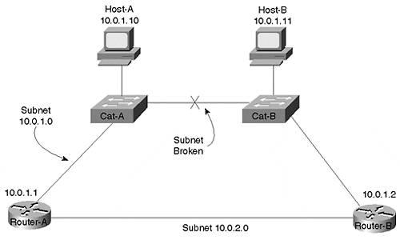
The link between Cat-A and Cat-B has failed, partitioning the 10.0.1.0 subnet into two halves. However, because neither router is aware of the failure, they are both trying to forward all traffic destined to this subnet out their upper interface. Therefore, Router-A will not be able to reach Host-B and Router-B will not be able to communicate with Host-A.
In general, there are two simple and effective ways to fix this problem:
- Utilize a mixture of Layer 2 and Layer 3 (such as with "routing switches"/MLS)
- Place only a single Layer 2 switch between routers (as well as between the "switching router" forms of Layer 3 switches)
Under the first approach, MLS is used to create a Layer 2 environment that, because it is redundant, remains contiguous even after the failure of any single link. Figure 15-18 illustrates this approach.

Figure 15-18 Avoiding Discontiguous Subnets With A Routing Switch (MLS)
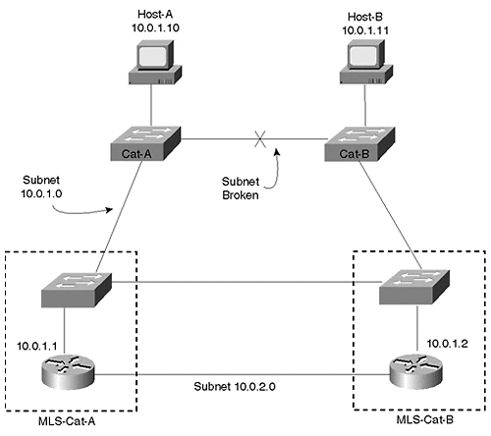
Figure 15-18 shows a logical representation of MLS devices where the Layer 2 and Layer 3 components are drawn separately in order to highlight the redundant Layer 2 configuration.
Note
The design in Figure 15-18 could also be implemented using switching router technology such as the Catalyst 8500s by utilizing bridging/IRB.

The second solution to the discontiguous subnet problem is to always use a single Layer 2 switch between routers, as shown in Figure 15-19.

Figure 15-19 Avoiding Discontiguous Subnets By Using a Single Layer 2 Switch
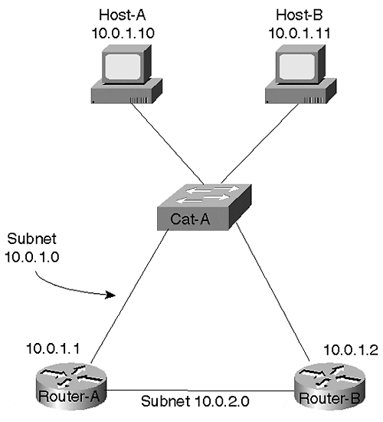
Because this eliminates the "chain" of Layer 2 switches shown in Figure 15-17, it allows any single link to fail without partitioning the subnet.

VTP
In some situations, the VLAN Trunking Protocol (VTP) can be useful for automatically distributing the list of VLANs to every switch in the campus. However, it is important to realize that this can automatically lead to campus-wide VLANs. Moreover, as discussed in Chapter 12, VTP can create significant network outages when it corrupts the global VLAN list.
When using VTP in large networks, consider overriding the default behavior using one of two techniques:
- VTP transparent mode
- Multiple VTP domains
First, many large networks essentially disable VTP by using the transparent mode of the protocol (there is no set vtp disable command). When using VTP transparent mode, you have absolute control over which VLANs are configured on each switch. This can allow you to prune back VLANs where they are not required to optimize your network.
Second, when organizations do decide to utilize VTP server and client mode, it is often beneficial to use a separate VTP domain name for each distribution block. This provides several benefits:
- It breaks the default behavior of spreading every VLAN to every switch (in other words, campus-wide VLANs).
- It constrains VTP problems to a single building.
- It allows the VTP protocol to better mirror the multilayer model.
- It can reduce Spanning Tree overhead.

Passwords
Because the XDI/CatOS-interface Catalysts (currently this includes 4000s, 5000s, and some 6000 configurations) automatically allow access by default, be sure to set user and privilege mode passwords. In addition, be certain to change the default SNMP community strings (unlike the routers, SNMP is enabled by default on XDI/CatOS-interface Catalysts).

Port Configurations
When configuring ports, especially important trunk links, hard-code as many parameters as possible. For example, relying on 10/100 speed and duplex negotiation protocols has been shown to occasionally fail. In addition, the state (on or off) and type (isl or 802.1Q) of your Ethernet trunks should be hard-coded.
Tip
One exception to this rule concerns the use of PAgP, the Port Aggregation Protocol used to negotiate EtherChannel links. If PagP is hard-coded to the on state, this prevents the Catalyst from performing some value-added processing that can help in certain situations such as Spanning Tree failover.

Review Questions
This section includes a variety of questions on the topic of campus design implementation. By completing these, you can test your mastery of the material included in this chapter as well as help prepare yourself for the CCIE written and lab tests.
1: | This chapter mentioned many advantages to using the multilayer model. List as many as possible.
2: | This chapter also mentioned many disadvantages to using campus-wide VLANs. List as many as possible.
3: | List some of the issues concerning management VLAN design.
4: | What are some factors to be considered when determining where to place Root Bridges?
5: | List five techniques that are available for campus load balancing.
6: | What is the primary difference between using routing switches (MLS) and switching routers in MDF/distribution layer devices?
7: | What are the pros and cons of using ATM?

